STUDENT REPORT ON GAME: ATLAS

PRESENTED BY:

GEORGE, GEORGE CHRISTOPHER

COURSE:

PROG 10004 PROGRAMMING PRINCIPLES

SUBMITTED TO:

MUHAMMAD ASIF

DATE SUBMITTED:

OCT 11TH, 2022

Story of the game:

You are a Mage/Bruiser in the kingdom of Atlas. The year is 1975, in the industrial revolution.

Your country is at war with the neighbouring and you have been asked for aid. This is your chance to show your worth.

Rise up and take a stand.

Roles within the game:

* Mage
* Bruiser

Stats/Attributes for each role:

|  |  |  |
| --- | --- | --- |
|  | Bruiser | Mage |
| Dexterity | 3 | 3 |
| Strength | 4 | 2 |
| Defense | 2 | 4 |

Code for the Mage (Role 1)

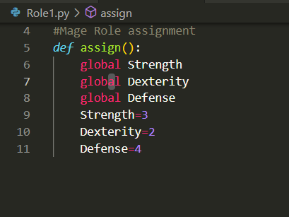

Code for the Bruiser (Role 2)

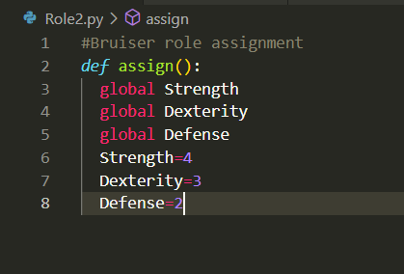

Code for App.py

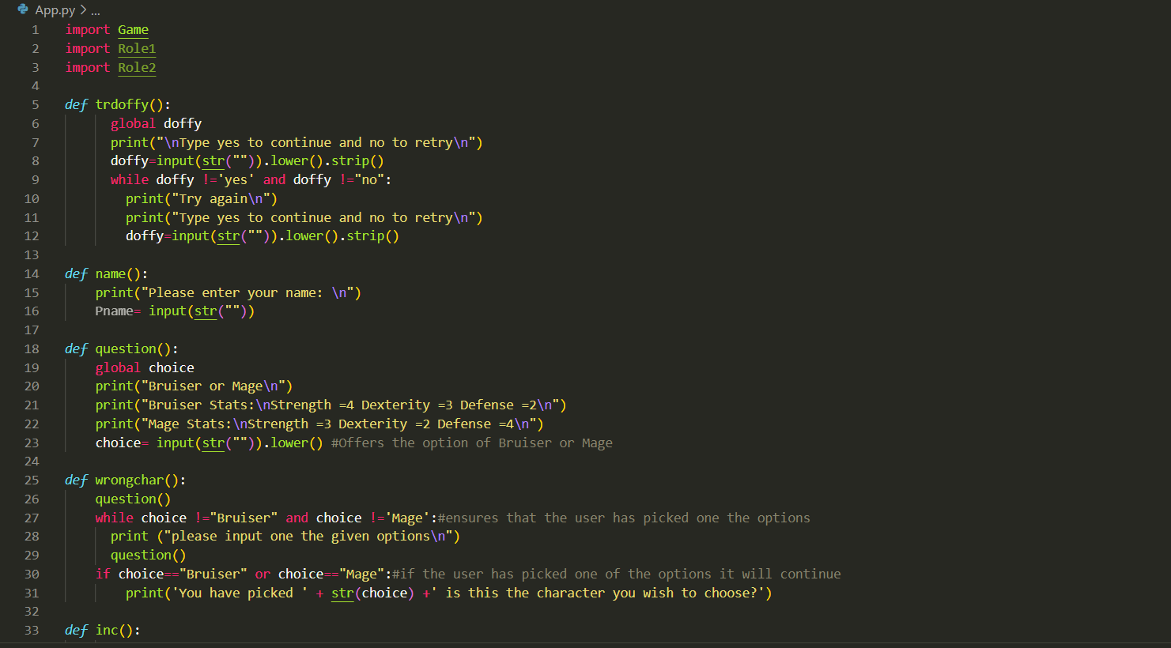

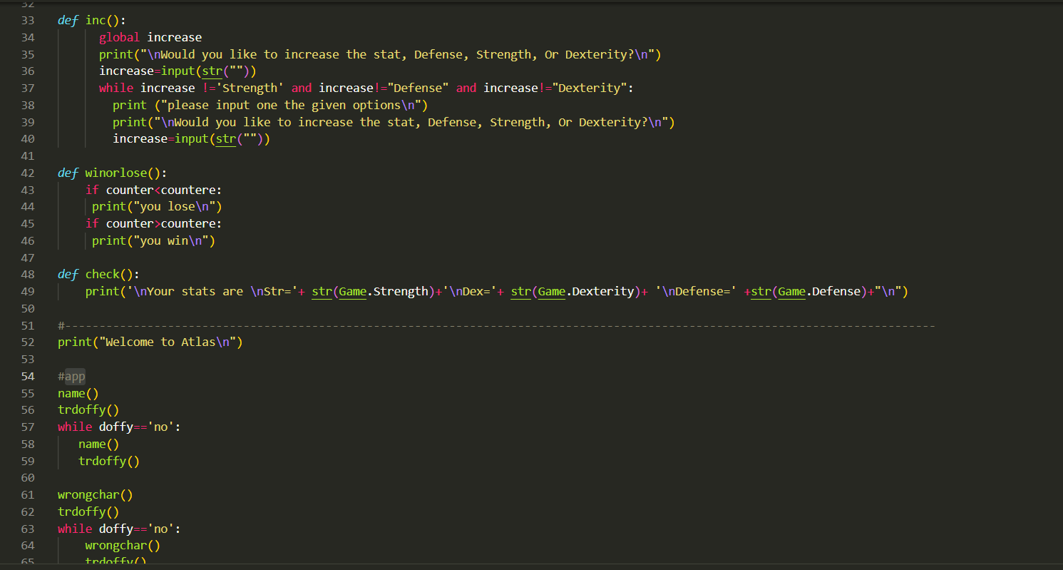

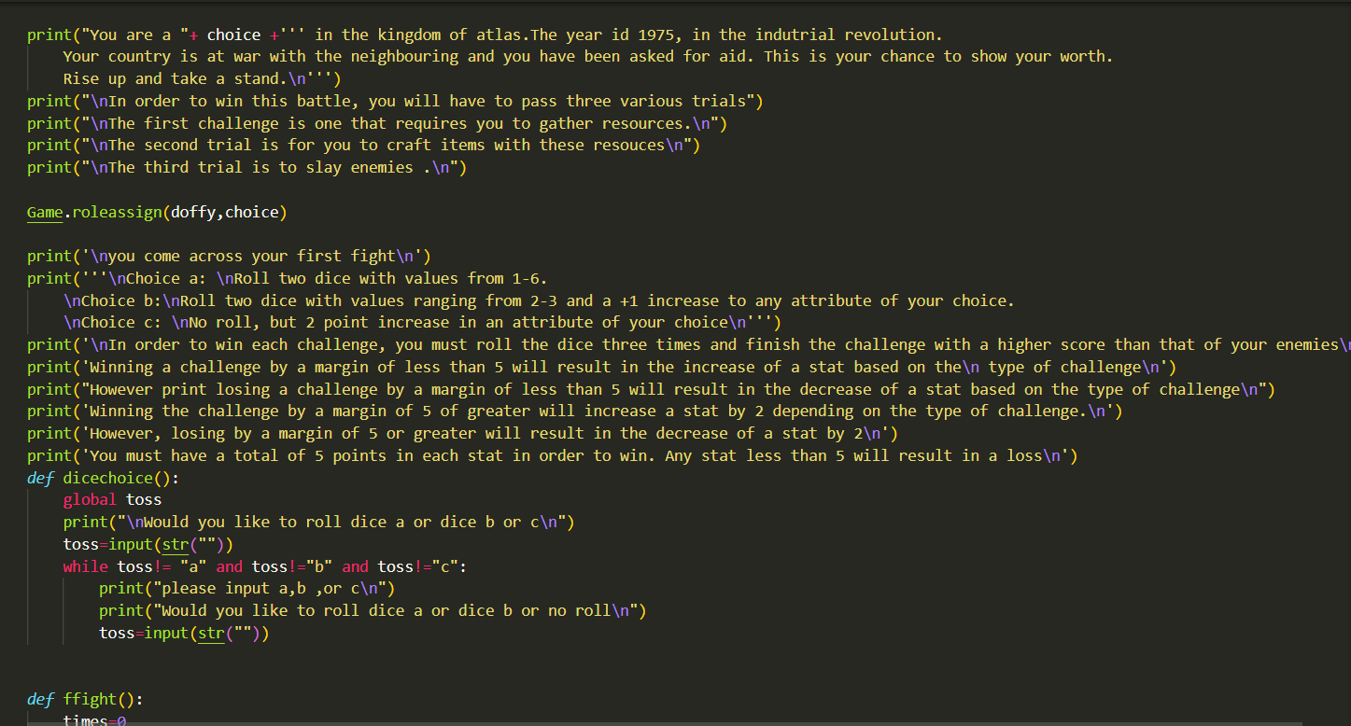

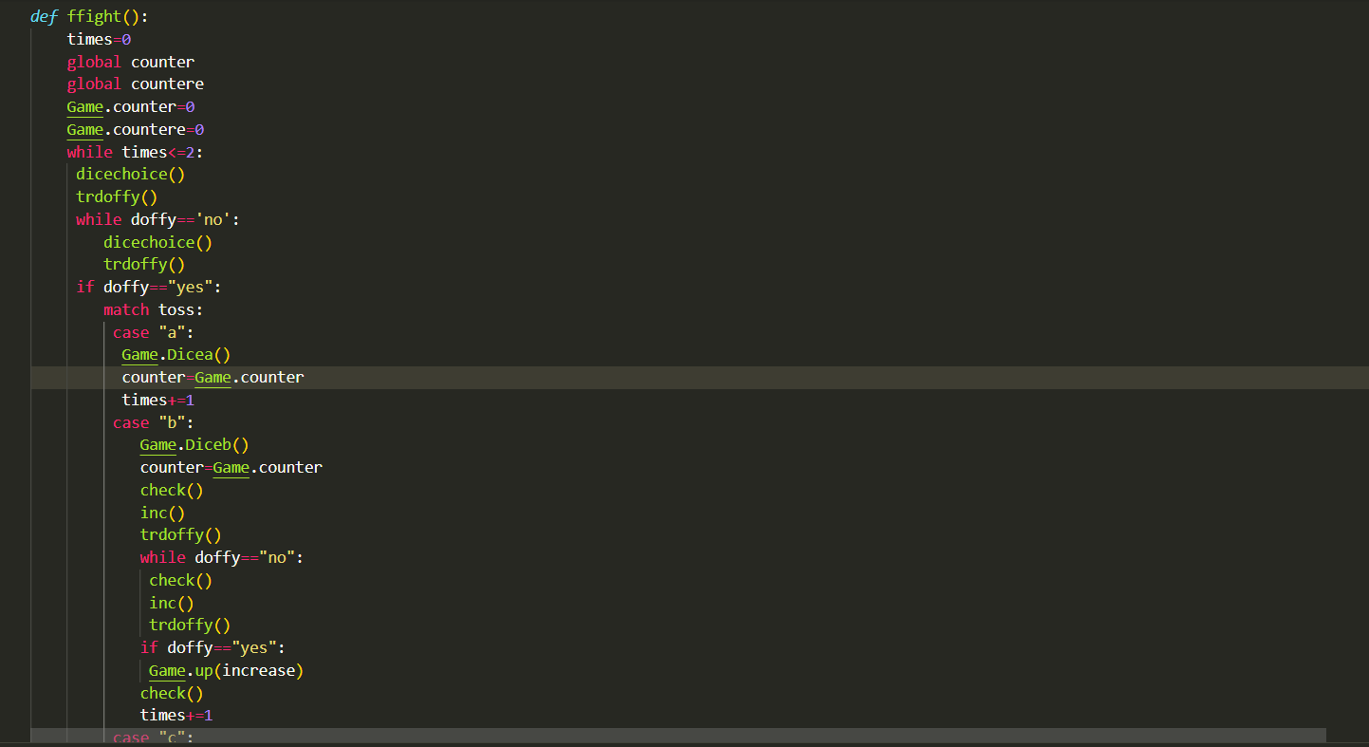

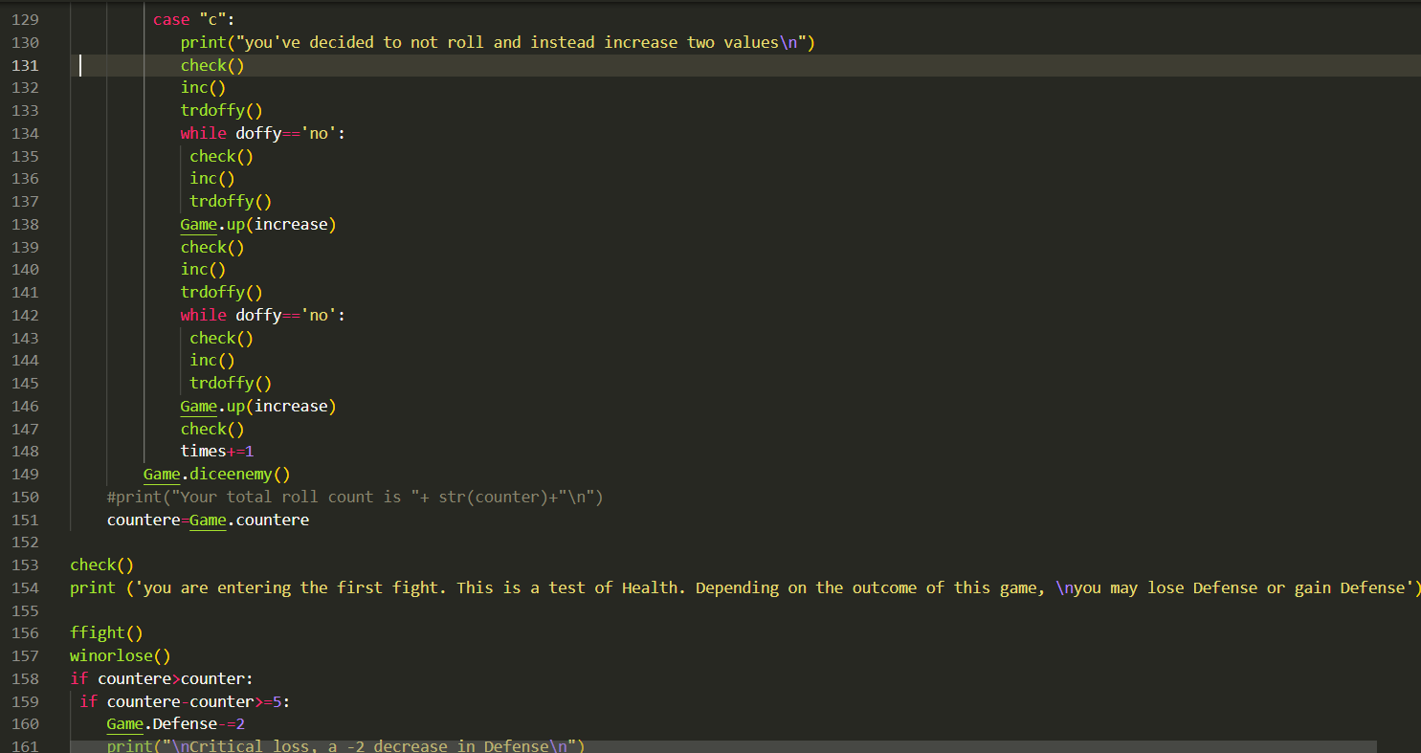

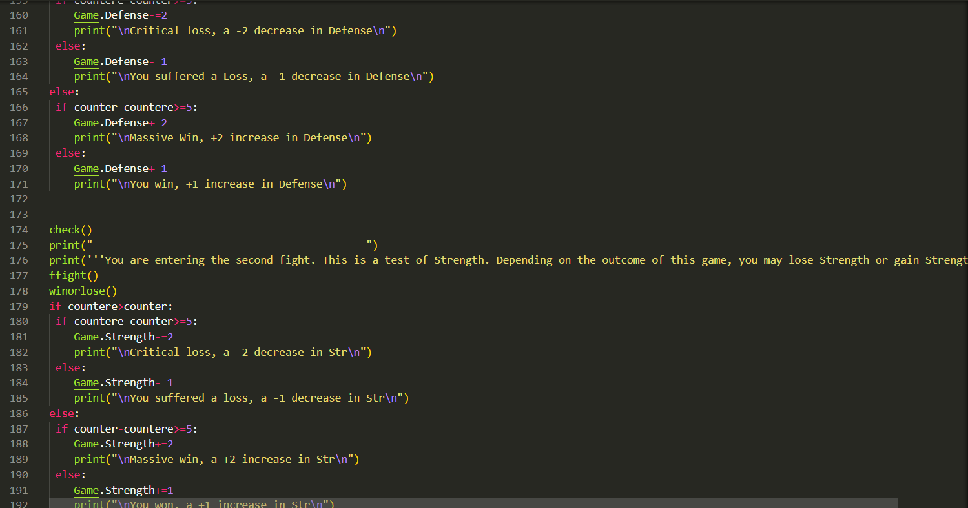

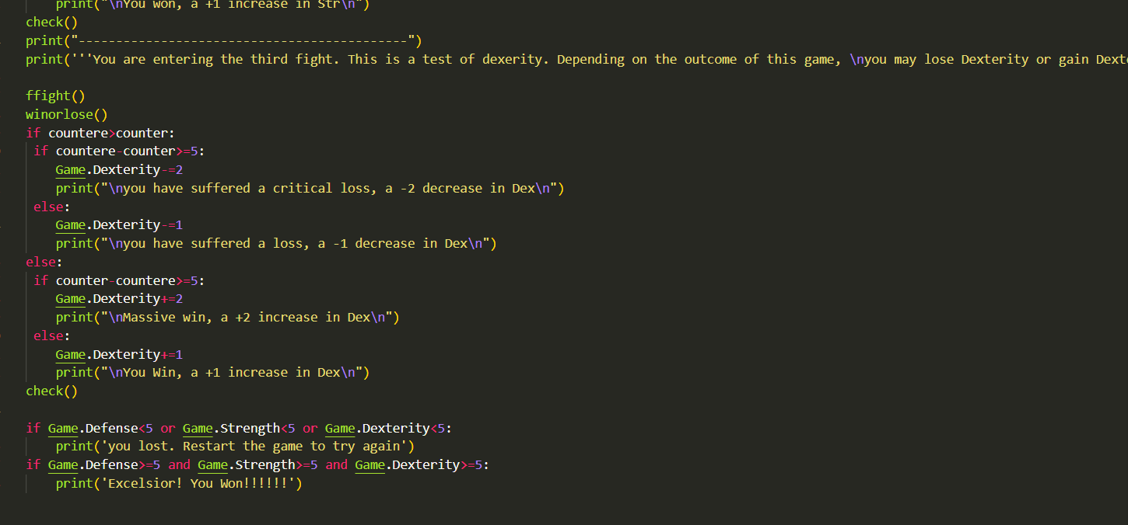

Code for Game.py

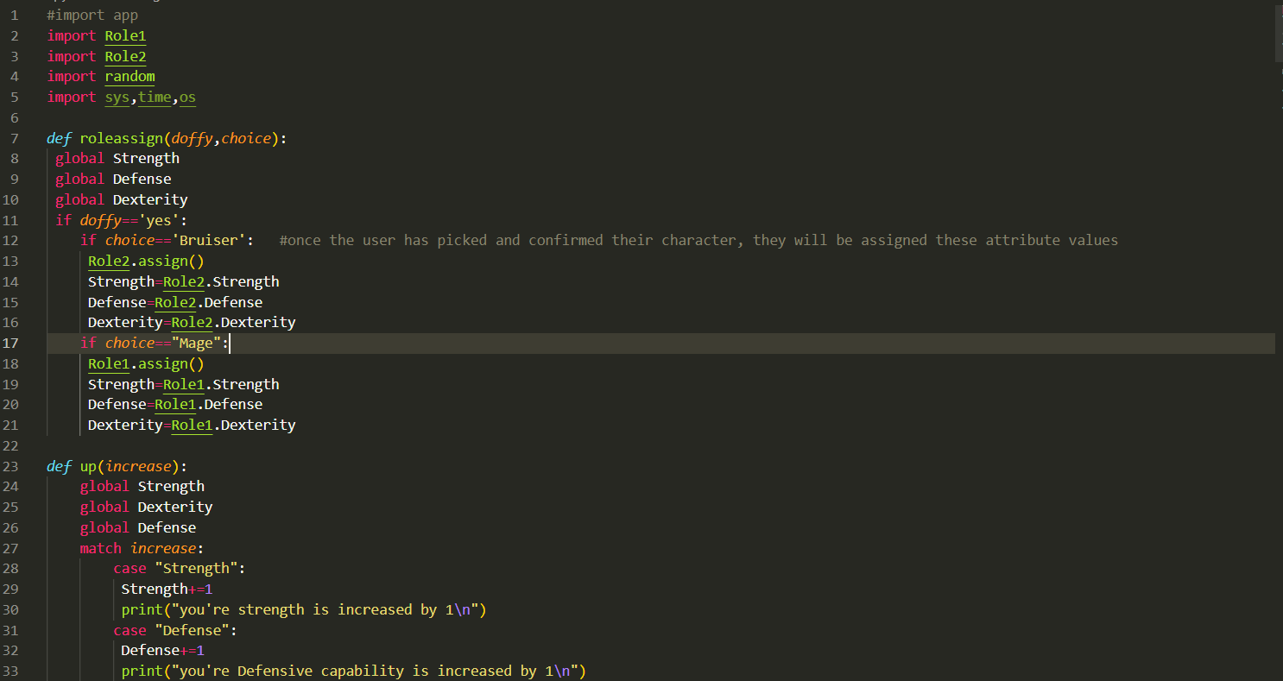

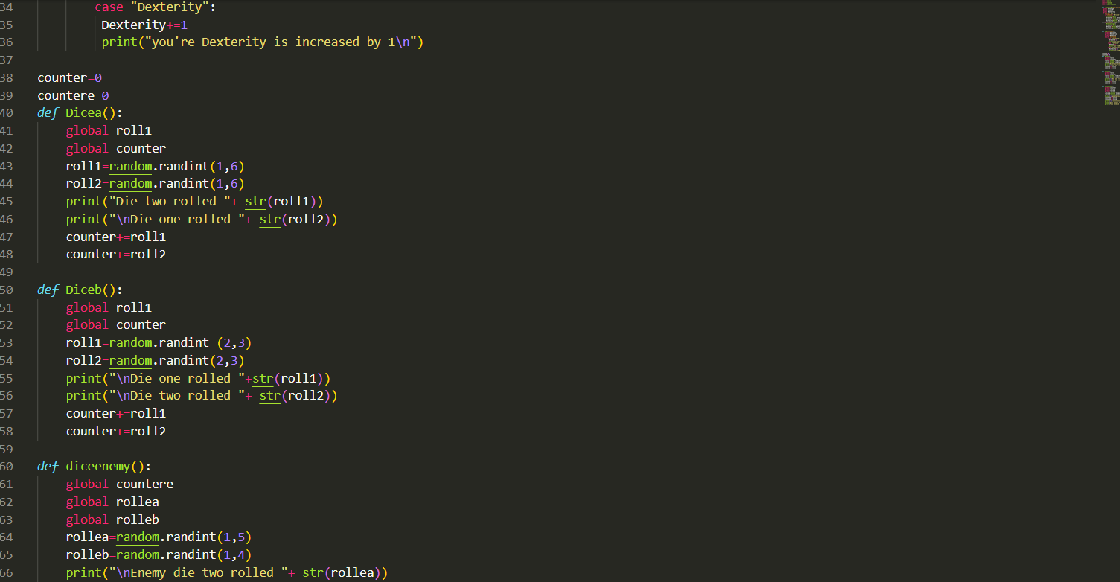

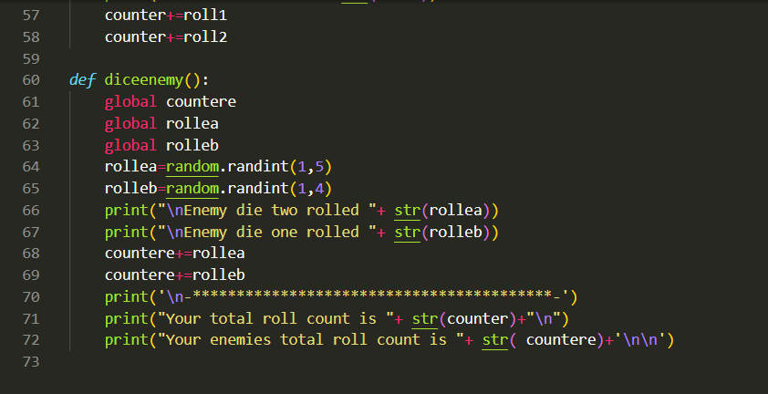

Game rules:

You are presented with three choices which guide you throughout the game. The choices are:

* Roll two dice with values from 1-6.
* Roll two dice with values ranging from 2-3 and a +1 increase to any attribute of your choice.
* No roll, but 2-point increase in an attribute of your choice.

In order to win the game, you must have all your attributes at 5 by the end of the game.

Difficulties experienced:

I ask my peers for aid and I was able to understand the idea of the code. However, despite finishing the code, formatting, and debugging. I am still not able to get the desired results. I have imported all the modules appropriately and made all the variables global so that they can be accessed by all the files.

The error I am presented with is this:

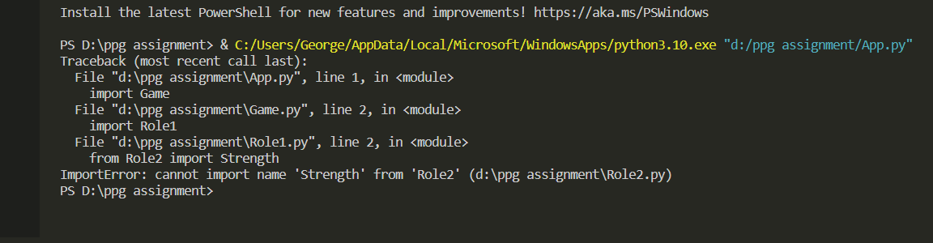

Link for access to GitHub repository: [georggeo23/ppg-assignment (github.com)](https://github.com/georggeo23/ppg-assignment)